Raspberry Pi Circuit Board:
Time Lapse Camera-
After researching the unique projects associated with the ‘Raspberry Pi’ Circuit Board, the one that caught my attention is ‘Time Lapse Camera’ which was put together using a ‘Blinkt addon’ of the Raspberry Pi board with the camera attached to a wearable item, creating access to see what the camera is seeing. A ‘Pi Camera’ and/or ‘Pi NoIR Camera’ with a compatible cable and Pi Board is also recommended for this tech set up. The ‘Python Program’ will be implemented to code the time-lapse portion of the ‘Time Lapse Camera’. Enable Camera beforehand.
The reason I chosen this piece is because not only can it be put together quite quickly but it also best demonstrates the many ways the Raspberry Pi can be incorporated into creative tech pieces. ‘Time Lapse Camera’ out of the rest of the tech pieces on the online article best demonstrates how a ‘Raspberry Pi Project’ should be constructed and can be used outside an exhibition in any location.
After overlooking this piece and the ‘Raspberry Pi’ technology I will seriously consider incorporating this as the main basis for the final piece for this module. Compared to other technology that has been taught over the last few weeks, this circuit provides the most features and assets that will be needed for the potential piece.

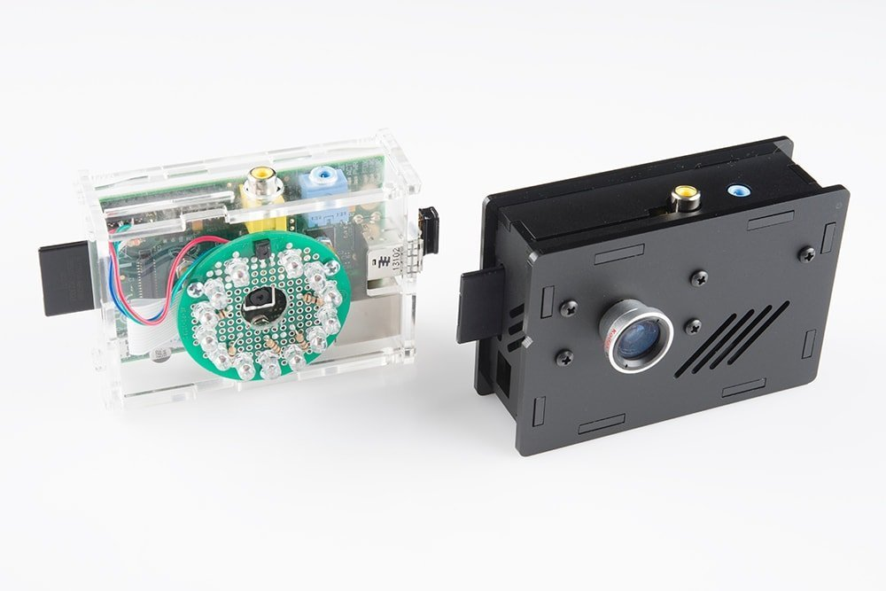
UbuntuPIT, 2020. Top 20 Best Raspberry Pi Projects That You Can Start Right Now. [online] Available at: <https://www.ubuntupit.com/20-best-raspberry-pi-projects-that-you-can-start-right-now/> [Accessed 12 February 2020].

Arduino Circuit Board:
Build a Kaleidoscope Infinity Mirror-
Researching the unique projects associated with the ‘Arduino’ Circuit Board, the one that caught my attention is ‘Kaleidoscope Infinity Mirror’ which creates an Infinity Mirror Illusion to the vision of the individual interacting with the piece. As the Mirror’s Orientation changes due to the interaction by the individual, a Kaleidoscope Effect is created. Colours that appear will vary based on how the mirror is manipulated. Many different effects (Including a psychedelic effect) can be created on the mirror itself.
Mirror Requires a set of LED lights along with an Arduino 101 board with the ‘Sparkfun’ version being recommended (a ‘Adafruit’s NeoPixels’ can also be used). The mirror will be powered by a set of AA batteries. A ‘Heat Shrink Tubing’ can be incorporated in the interactive mirror.
The reason I chosen this piece is due to how this could provide a good basis for possible ideas when development of the final piece commences as it will be a visually fun piece if pursued for the exhibition at the end of this module.
Despite the interaction with the circuit during Week 4’s session and further research into this Hardware and Software, I don’t see myself (whether by myself or in a group) using this technology for the final piece as the main focus. This is due to its lack of flexibility and variety in what it offers as a piece of equipment and even if it is considered into a potential final piece it would only function a small factor of the piece as a whole (i.e. turn on/off a specific function on the piece itself).
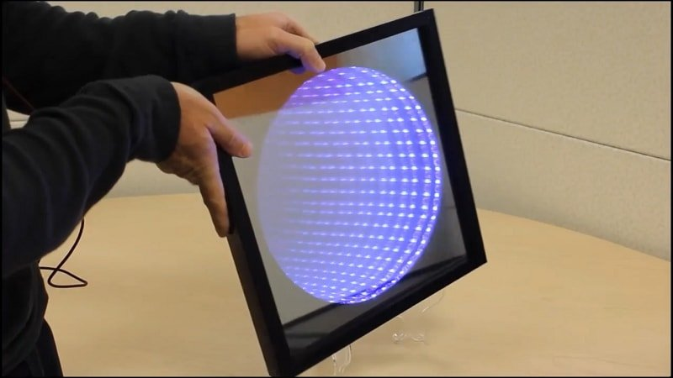
UbuntuPIT, 2020. Top 15 Best Arduino Projects That You Can Build Right Now. [online] Available at: <https://www.ubuntupit.com/top-15-best-arduino-projects-that-you-can-build-right-now/> [Accessed 12 February 2020].

