LOOMIA’s Stylish e-textile jacket (E-Textile);
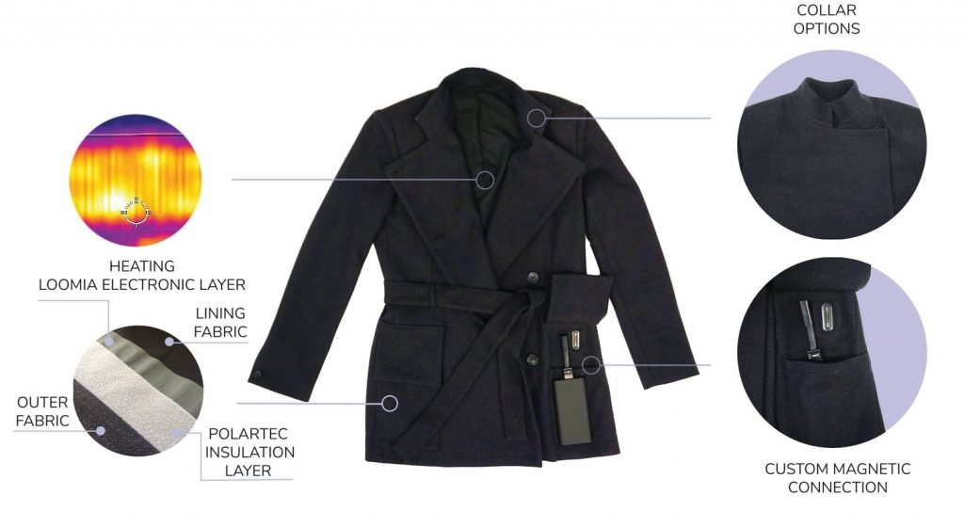
An effective e-textile piece that I uncovered for the research performed during Week 5 is the ‘LOOMIA’s H1 jacket’ which has a heating function created by the designer ‘Mari Kussmann’. The integrated heating in the jacket is powered by an external battery made to a size like batteries found in a smartphone. The battery in effect disappears into a pocket within the jacket which is connected to a garment via a magnetic connector.
Heating Function has an on/off switch and the heat intensity is controlled through a regulator. The jacket is manufactured using an ‘ISO 9001-certified machine’ (from Easyprint) that implemented sustainable materials and a Polartec lining.
The reason I chosen this particular ‘E-Textile’ is not only due to its use of a heating device within a jacket (keeping the occupant warm) which makes a nice distinction from other ‘E-textiles’ that mostly focus on LED Lights and technology applied on the outside rather than the inside of the jackets (or other fashion clothing); it also factors in the need of having sustainable materials to create the ‘E-Textile’ with no issues with the said clothing contributing to unnecessary waste as well as being easy to refashion or recycle into other products once it fulfilled its initial use.
The possibility of working with a Fashion Designer within the University (Graduate Student or a Student doing their Masters) is an intriguing proposition which is something I will bear in mind in the further development of the final idea both through written notes and through proper experimentation with one of the circuits (technology) taught over the early weeks within this Module. Even if this isn’t pushed further into development, I wouldn’t mind considering this idea/concept for the Third Year of the Digital Media course if any of the modules during that period open up the doors for further development of mimicking this particular ‘E-Textile’ piece.
Bibliography;
Promotex-expo.com, 2020. Of wearables, e-textiles and a smart jacket | PromoTex Expo. [online] Available at: <https://www.promotex-expo.com/en/of-wearables-e-textiles-and-a-smart-jacket/> [Accessed 19 February 2020].
Baja East x Fila Smart Shoes (Wearable Tech):
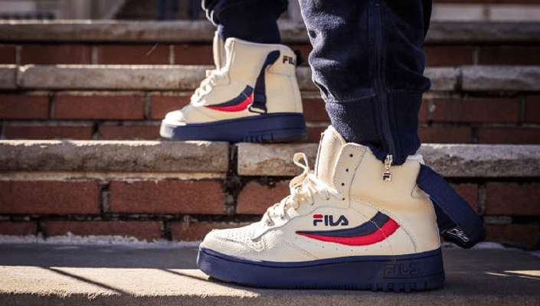
A Unique ‘Wearable Tech’ that I have uncovered is a Wearable Fitness Tracker attached to a pair of shoes. These shoes are made to participate in the fast-growing market of ‘Wearable Fitness Trackers’, with the Smart Shoe being able to track and interpret fitness data. The Smart Shoes are produced by Fila who collaborated with the West Coast luxe designers.
The factors that encouraged me to choose this variant of the ‘Wearable Tech’ compared to the other four ‘Wearable Tech’ pieces that are present in the site (referenced below) is it is the most productive and original of the lot. Unlike the other pieces, this piece opens the opportunity to provide creative choices to the design of the shoes themselves as well as appeal to a larger market which I felt was lacking in the other pieces present on the site.
Although, unlike the ‘E-Textile’ piece I uncovered for this research, the Wearable Fitness Tracker could be recreated within a decent timeframe this module allows and wouldn’t be too costly in the materials needed. Despite this benefit I won’t be pursuing this idea for the final piece as at the time I written this down it isn’t a concept that really inspires me while the other ideas (particularly the ‘e-textile jacket’ from the previous page) provide more interest to me. Even if the idea was pursued it would become apparent that only a select number of people could wear the shoes, so it wouldn’t be put into much practise in the final exhibition if it was made.

Bibliography;
mobiloitte.com, 2016. 5 Coolest Piece of Wearable Tech at New York Fashion Week. [online] Available at: <https://www.mobiloitte.com/blog/5-coolest-pieces-wearable-tech-new-york-fashion-week/> [Accessed 19 February 2020].

