The first game that caught my eye while researching various games on the Open Processing programme is called ‘Wolf Tile Game’. This game focuses upon rearranging squared images to line up to create the full create image.
A Makey Makey Circuit with a Joystick can also be applied to both games that are present in this Word Document. The inclusion ‘Zero One’ Generative Video is something I’ll seriously consider for the idea of the touch sensitive window piece. The ‘Zero One’ interactive piece was introduced during the scheduled lesson in Week 3.
The complex coding to achieve this highly detailed game can be accessed and replicated for future games and tutorials for students in schools in universities. A screenshot of the game itself can be seen below;
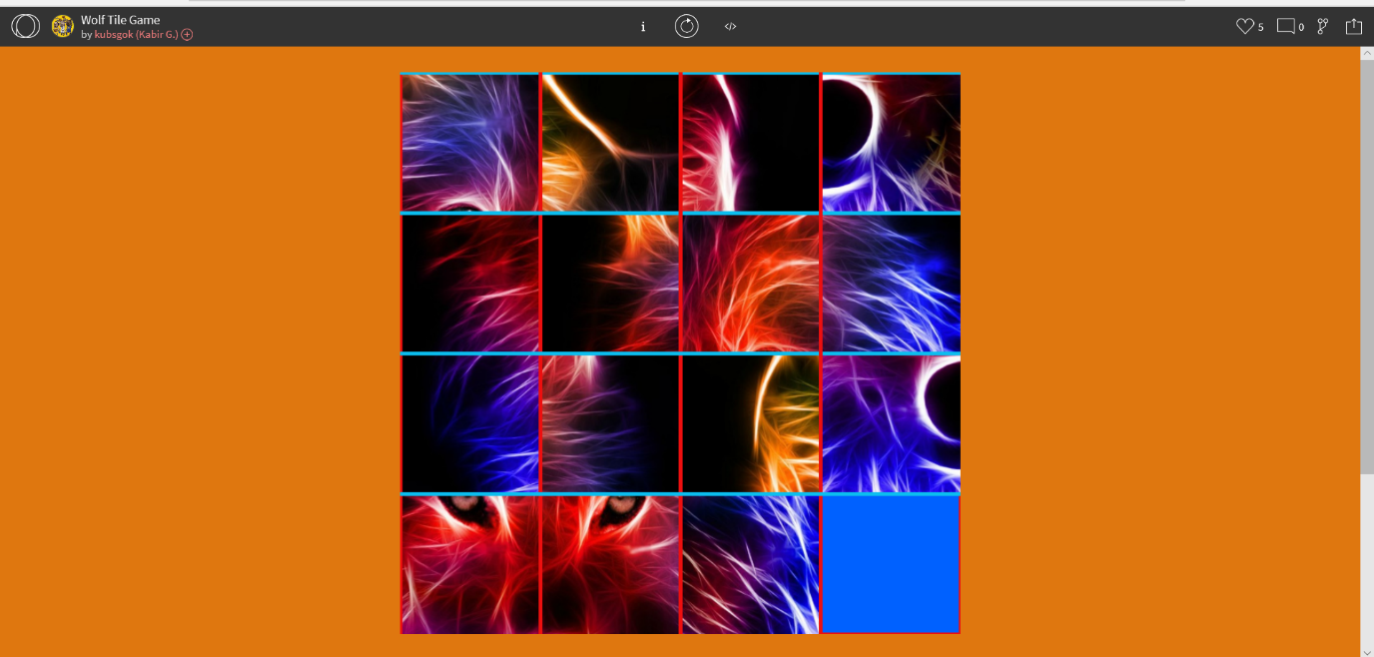

Bibliography:
OpenProcessing, 2020. Wolf Tile Game – OpenProcessing. [online] Available at: <https://www.openprocessing.org/sketch/543964> [Accessed 05 February 2020].
OpenProcessing, 2020. Space Shooter Game – OpenProcessing. [online] Available at: <https://www.openprocessing.org/sketch/753523> [Accessed 05 February 2020].

The second game that I came across while performing research for Open Processing is called ‘Space Shooter Game’. This game functions in the same way the classic ‘Space Invaders’ operated with the major difference being the spaceship zooms through space shooting asteroids/planets rather than the ship being placed in the centre of the screen shooting at spinning asteroids coming towards it.
Like the ‘Wolf Tile Game’, the complex coding to achieve this highly detailed game can be accessed and replicated for future games and tutorials for students in schools in universities. A screenshot of the game itself can be seen below;
