The first moving tech piece that uses a Servo Motor is called a ‘Dancing Lego and Five Servos’ by Pierre Villeneuve which functions by incorporating five hoppy servos to a Lego model. This is controlled by a ‘Control Board Board’ and a ‘Raspberry Pi Circuit’. This was a way of controlling a Lego Robot without utilising Lego’s own robotic components. An extra feature Pierre incorporated into this project was creating a histogram of a royalty free music track that he found and synced the motors movement to the beat of the music in question.
The reason I chosen this piece of tech is I felt this best demonstrated how a 360 rotor connected to a Raspberry Pi or a Raspberry Pi Circuit on its own can contribute in creating interesting working machines which is prevalent in the ‘Dancing Lego and Five Servo’s’ project moving in unison with royalty free music.
Although it is has been demonstrated via research and in scheduled lessons in the university that implementing a 360 Rotor through a Raspberry Pi can lead to very creative and innovative moving contraptions; I won’t be pursuing this form of ‘Interactive Tech’ for the final piece that I will produce in cooperation with Uttara Srikanth. Despite these conclusions I will consider this for one of the modules that will be presented in the third year of the Digital Media if the topic of ‘moving tech’ suits the module in question.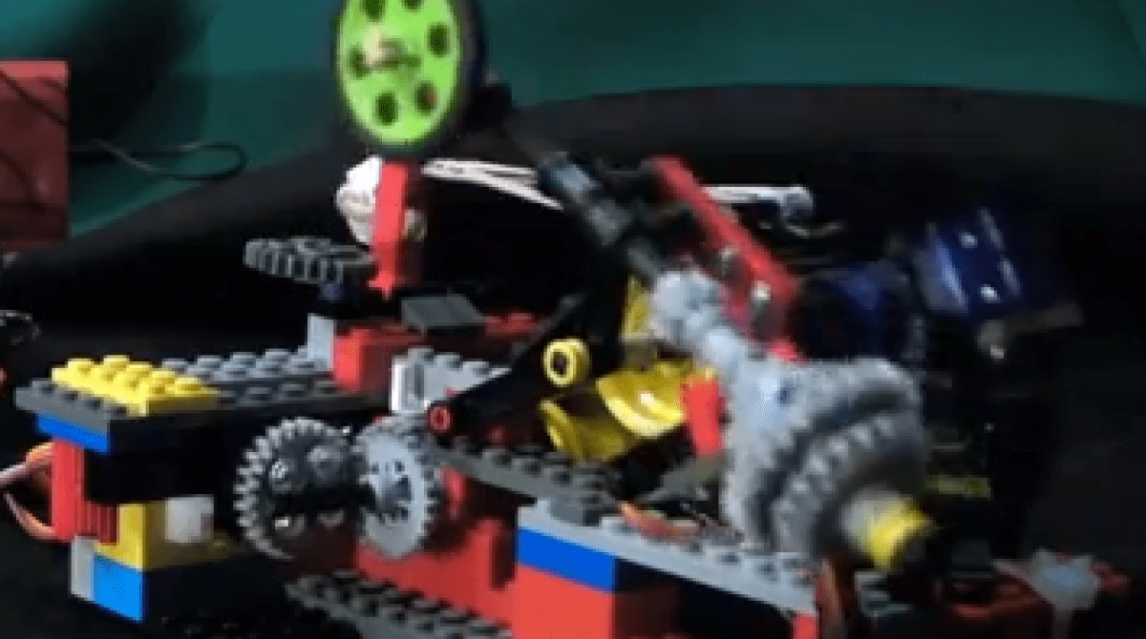

The second moving tech piece that I have uncovered while searching for creative servo motor pieces (via Raspberry Pi) is a project called ‘DIY Raspberry Pi Drone’. It is a Quadcopter capable of taking high quality aerial photos and stabilized HD Videos in mid-air. Its components include a Raspberry Pi (provide access to live streams delivered to a mobile device via Raspberry Pi) and a Linux computer which provides additional sensors, computer vision etc.
The reason I chosen this piece is due to how it stuck out the most to me when I was initially doing research on the topic of ‘360 Rotors’ with a very in-depth website demonstrating how to create your own ‘drone’ from scratch. The availability of the sites that give out the step by step in how to create this technology is also something that should be commended upon as there aren’t many sites that I can think of that showcase how each creative tech piece is made.
Like the other piece I found while doing research for ‘360 Rotor’ pieces is although I won’t consider this for the final piece within this module, it would be worth something to bear in mind when developing work for this courses final year. This unique tech variant I feel is more effective in integrating the ‘360 rotor’ feature that accompanies the Raspberry Pi rather than the ‘Dancing Lego and Five Servo’s’ piece.
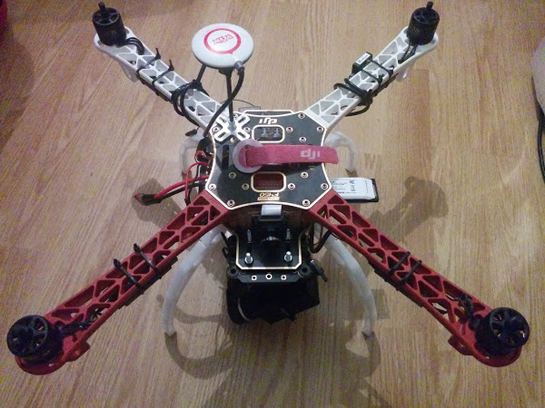

Bibliography;
makecode.microbit.org, 2020. Microsoft MakeCode for micro:bit. [online] Available at: <https://makecode.microbit.org/#editor> [Accessed 28 February 2020].
kitronik.co.uk, 2017. Control A 360 Degree Servo With A BBC micro:bit – Kitronik. [online] Available at: <https://www.kitronik.co.uk/blog/control-a-360-degree-servo-with-a-bbc-microbit/> [Accessed 28 February 2020].
Makezine.com, 2013. Controlling 5 Servos With a Raspberry Pi. [image online] Available at: <https://makezine.com/2013/05/21/controlling-5-servos-with-a-raspberry-pi/> [Accessed 28 February 2020].
deviceplus.com, 2016. DIY Raspberry Pi Drone : Mechanics – Part 1. [image online] Available at: <https://www.deviceplus.com/raspberry-pi/diy-raspberry-pi-drone-mechanics-part-1/> [Accessed 28 February 2020].

