Unique ‘Makey Makey Circuit’ Pieces:
A YouTube video expands upon several interactive pieces that incorporated the ‘Makey Makey Circuit’ into its main set up as well as an image below showcasing the game controls made specifically for the circuit (It’s also worth considering the touch sensitive aspect of the circuit which was taught in Week 2 sessions).
The pieces that stood out to me in the video are as follow:
- ‘Musical Water’ (Tins of water connected to ‘Makey Makey Circuit’ to create piano noises/tunes).
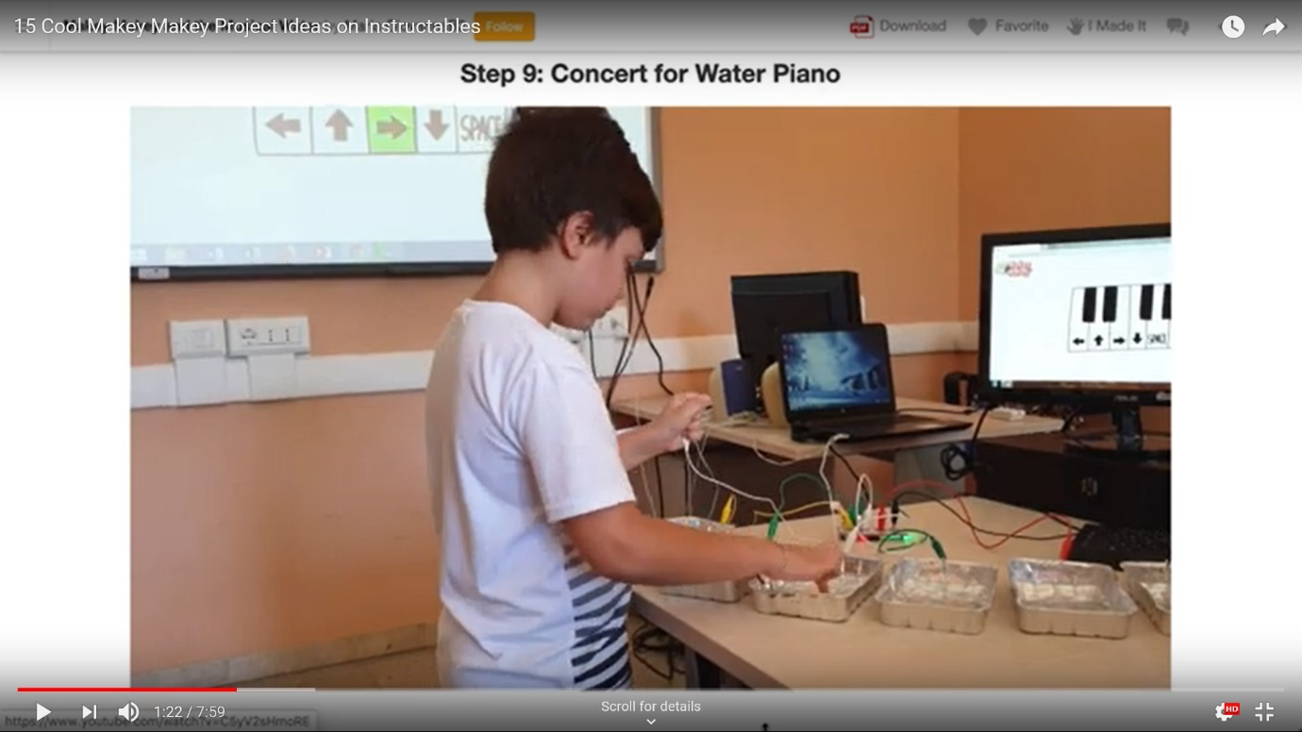
- ‘Exit Ticket Collector’ (Visual Buttons used for people to explain how they feel. If the person is happy, they press the happy face).
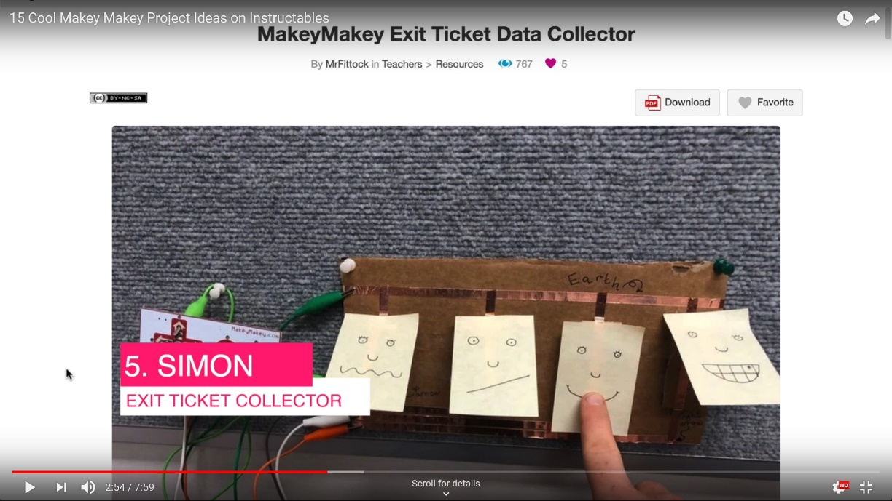

- Smart Racing Track Game.
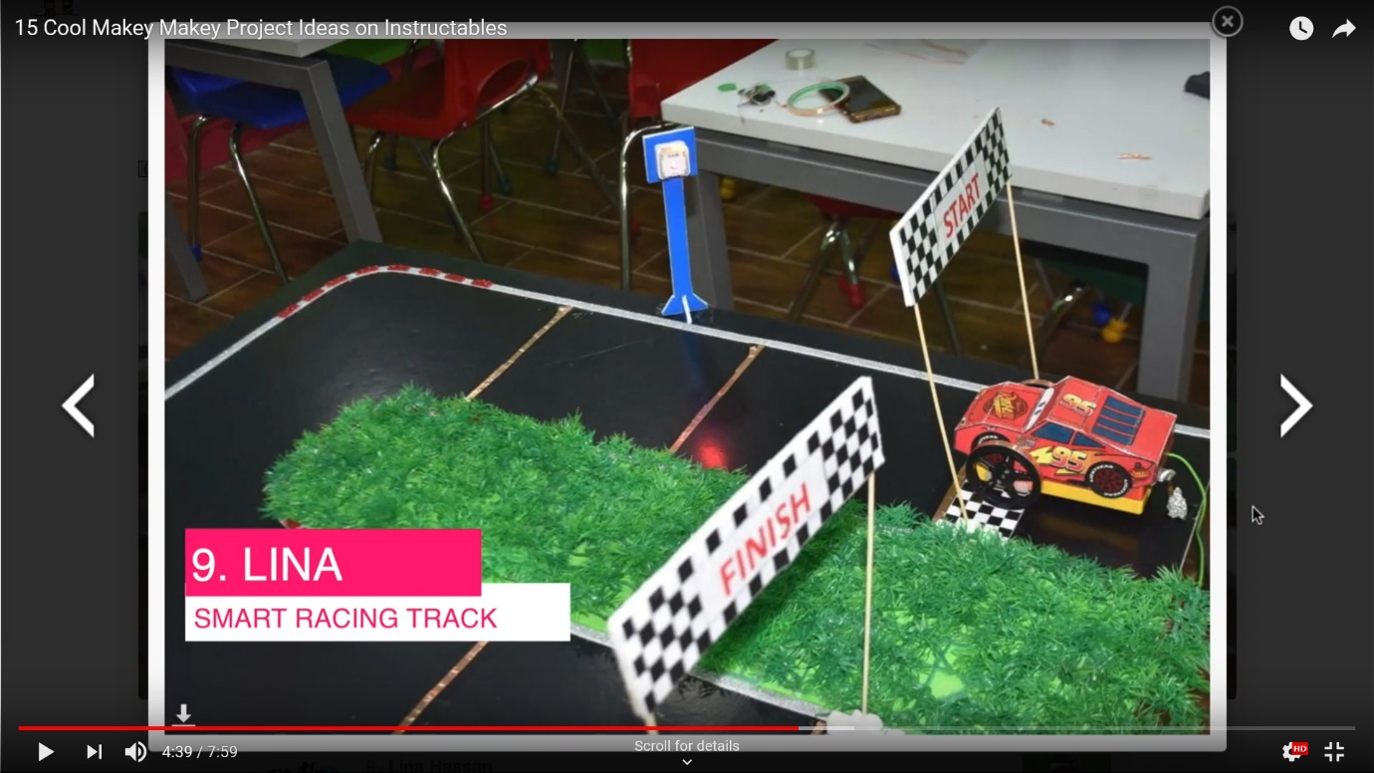
- Light up House/Street (Showcase how a house or neighbourhood works and how to maintain the streets/houses power).
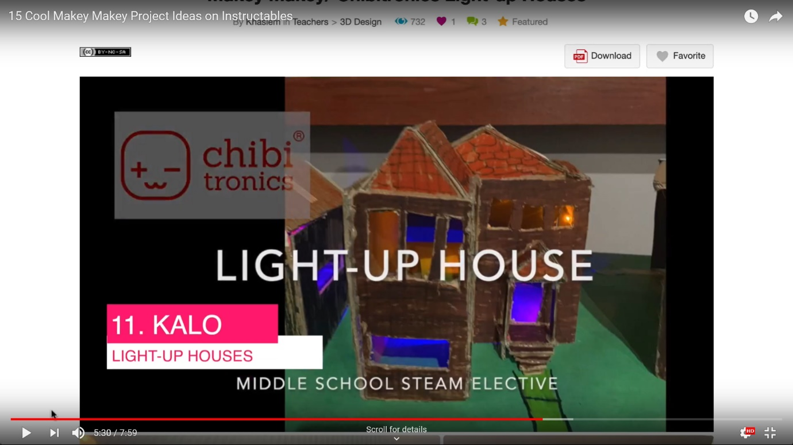

- Human Body (Learn about Body parts) This can also relate to planets in the Solar System which can be seen on this page via another screenshot from the YouTube video.
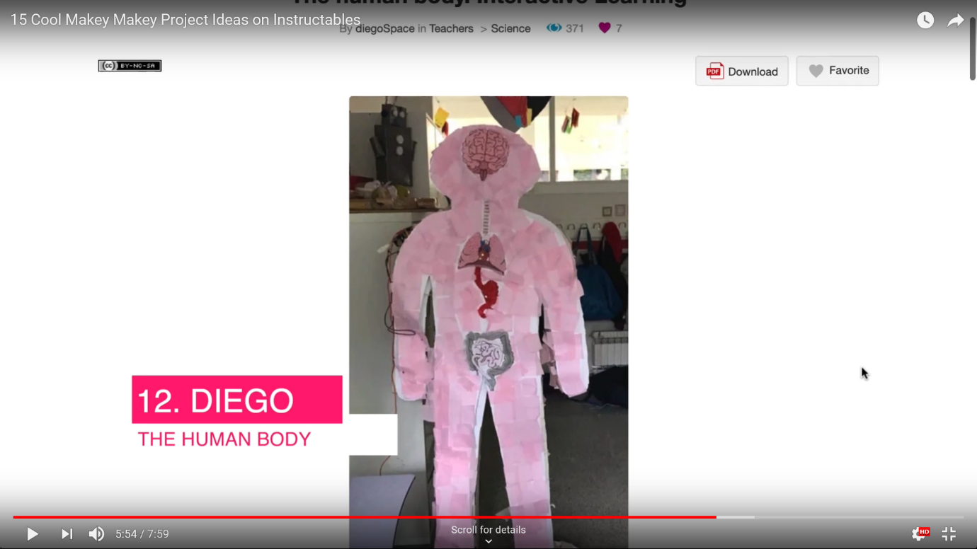
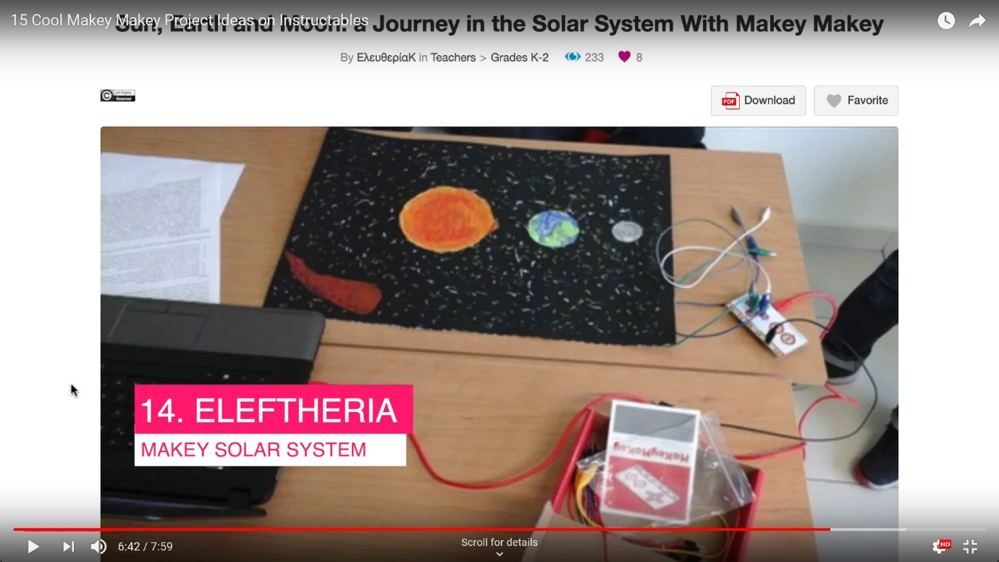
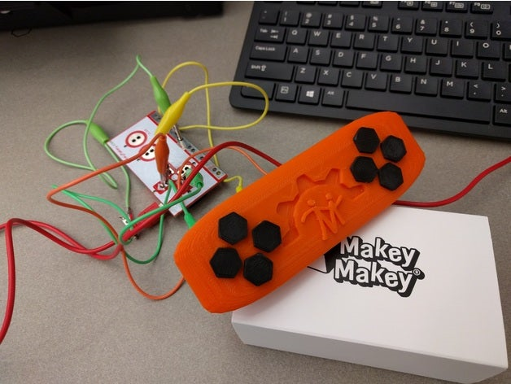
Bibliography:
Surfing Scratcher, 2019. 15 Cool Makey Makey Project Ideas on Instructables. [video online] Available at: <https://www.youtube.com/watch?v=NCtW0YNJpYQ> [Accessed 29 January 2020].
Thingiverse, 2017. Makey Makey Video Game Controller by TonyMORIC – Thingiverse. [image online] Available at: <https://www.thingiverse.com/thing:2461201/comments> [Accessed 29 January 2020].

Unique Squishy Circuit Pieces:
After searching up unique ‘Squishy Circuit’ pieces it became clear that this circuit configuration is used mainly for children’s activities that involves various animals, vehicles and plants with the added lights.
An entire site is dedicated to expanding on giving out step by step tutorials (YouTube Videos, Apps, Social Media etc.) to encourage children or their parents to create these ‘Squishy Circuit’ Pieces. The site also provides pages on ‘Education’, ‘A Shop’ and Galleries containing various projects that expand on the ‘Squishy Circuit’ Piece Installation.
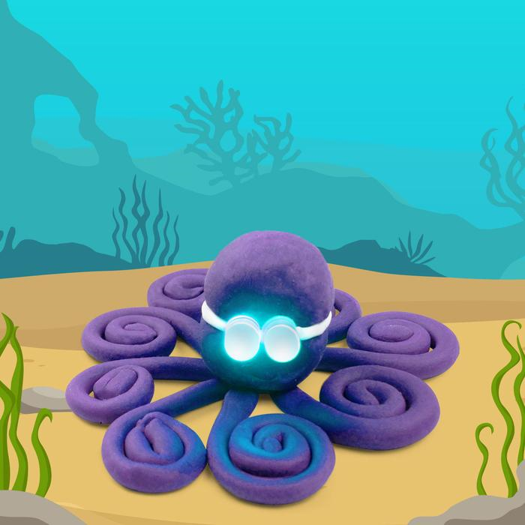
Bibliography:
squishycircuits, 2020. Projects Creation Gallery | Electric Circuit Project Inspiration. [online] Available at: <https://squishycircuits.com/collections/projects> [Accessed 29 January 2020].
squishycircuits, 2020. Octopus | Squishy Circuits Creations. [image online] Available at: <https://squishycircuits.com/collections/projects/products/octopus?variant=31568382853167> [Accessed 29 January 2020]

